POSTING NOTICE
COMMITTEE: | Rehoboth Cultural Council
DATE: | Tuesday, September 28th, 2021
TIME: | 7:00 p.m.
LOCATION: | Goff Memorial Hall  124 Bay St Rd, Rehoboth, MA 02769
AGENDA: | See Below
AGENDA
- Elections: Secretary
- Review and approve June 1, 2021 meeting minutes
- Treasurer’s Report
- Continued Discussion on 2021 Grants
- Discussion on Community Input Survey
- Continued Discussion on Social Media
- Vote to Approve 2022 Guidelines
- Discuss Voting Meeting (Late November)
- Adjourn

POSTED: | Date September 22, 2021 Time
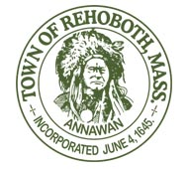
 | Laura L. Schwall ~ Rehoboth Town Clerk

